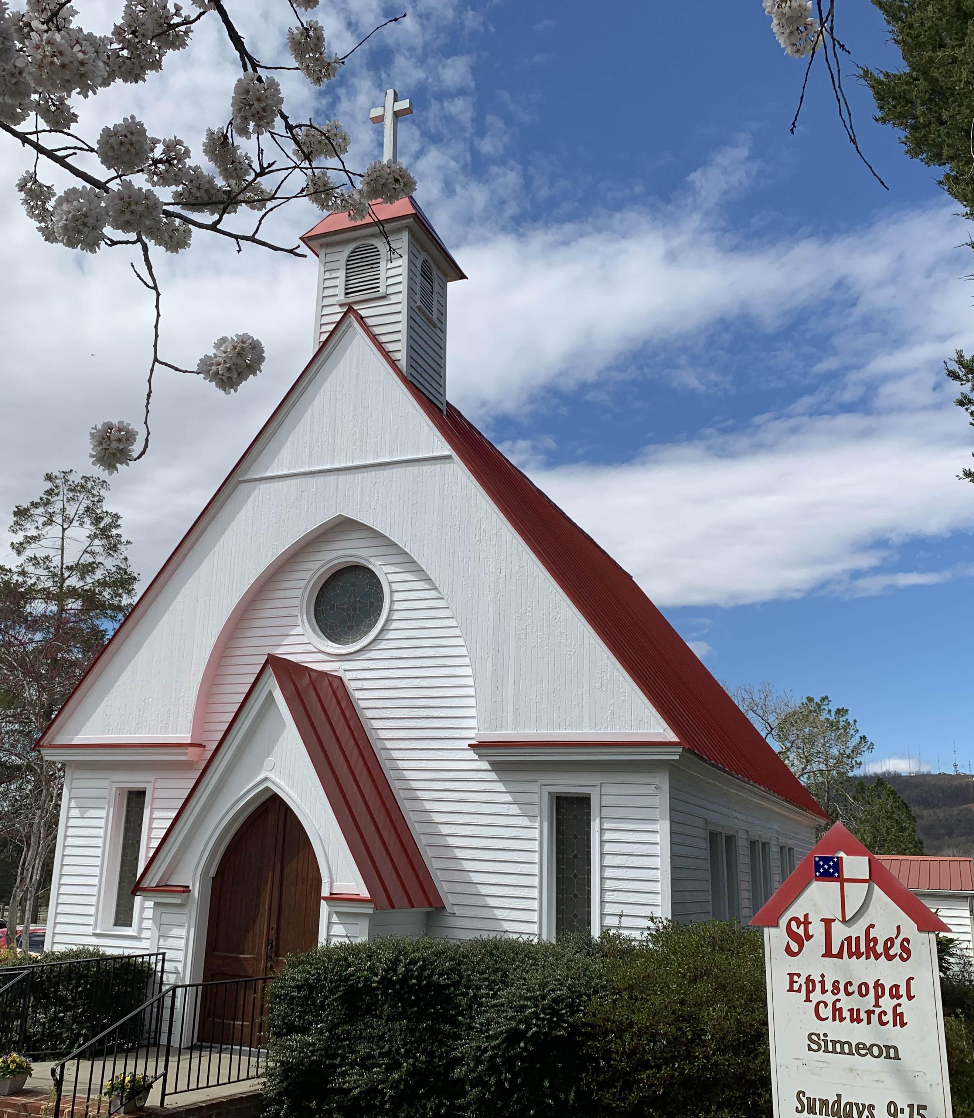

Come to St. Luke’s Simeon!
Join us for a day of fun, shopping, and fellowship!
We’ll have a wide variety of vendors and fun activities for children.
All proceeds are given to local charities!

Fall FestivaL

  - Saturday
November 1, 2025
9:00-2:00
St. Luke’s, Simeon Episcopal Church
1333 Thomas Jefferson Parkway
Charlottesville, VA 22902

